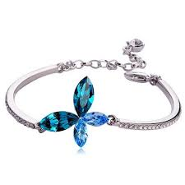  
This bracelet is an ultimate expression of romance. With the enhanced technical mastery, it represents everlasting appleal and can match all special occasion. Magnificent Blue flower placed with Brass make this bracelet simply fantastic.

Product: Flower Bracelet

Price: 1500 PKR

CONTACT US: Address: Aptech Metro star Gate Karachi

Email: feedback@aptech-education.com.pk